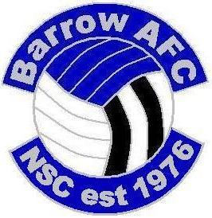

**All entries to be received no later than 18th November 2022**

**Barrow AFC (National) Supporters Club**

**World Cup 2022**

**Predictions Competition**

***Rules***

£3 per entry or £5 for 2 entries

***Scoring:***

All Matches

Correct result 2 point

Correct result & score 5 points

Example: **England 1 Iran 0**

If you have predicted **1-0**, you will get **5** points for the right result and score

If you have put **3-0**, you will get **2** points for the right result

If you have put **1-1** or **0-1** etc. you will get **0** points

Predict 2nd Round, Quarter Finalists, Semi finalists, Finalists and the Winner :

5 points for each correct team into 2nd Round (last 16)

10 points for each correct Quarter Finalist.

15 points for each correct Semi Finalist.

20 points for each correct Finalist.

25 points for correct 3rd Place team

30 points for the Winner.

Looking forward to the World Cup in November? Well, why don’t you try your hand at predicting the scores, and eventual World Champions in our competition.

**Prizes**

**First** – 4 x Hospitality Tickets for home game at “So Legal” Stadium 22/23 and signed Barrow AFC Shirt. ***Kindly provided by Barrow AFC***

**Second** – £40

**Third** - £20

Send all entries to:-

Chris Roddie

“Claremont”

Wolverhampton Road e-mail : chris_roddie@hotmail.co.uk

Penkridge Tel 07743 095878

Staffordshire

ST19 5AQ

**Please make all cheques payable to “Barrow AFC (National) Supporters Club”**

**Electronic Transfer: Sort Code 05-02-00**

**Account Number 29823284 (Put your name as reference)**